Click on the below link to clink on download button.
https://drive.google.com/file/d/1r8Uk7evS0lXwYRaLJ5O3e9Drw-izOImx/view?usp=drive_link
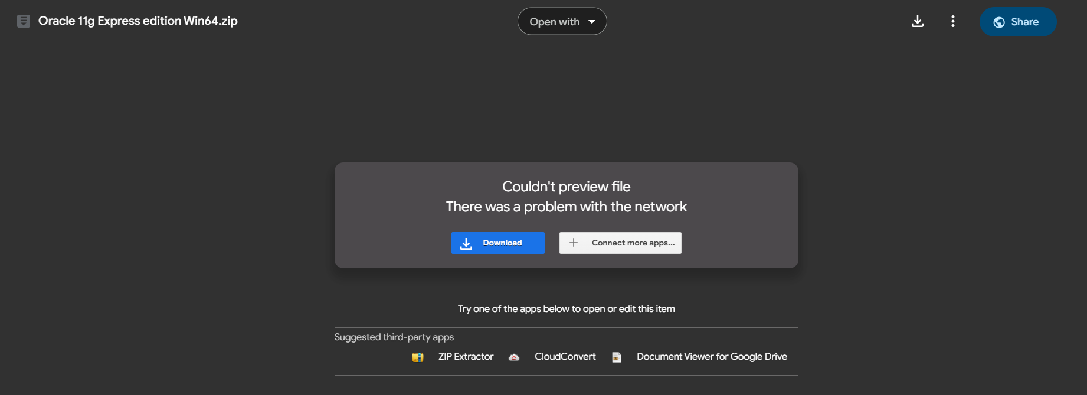

Once download completed go to Download folder then
- Copy it
- Go to Desktop or Any other Drive
- Create New Folder with name as SQL
- Inside SQL Folder paste it.
- Now extract the file.
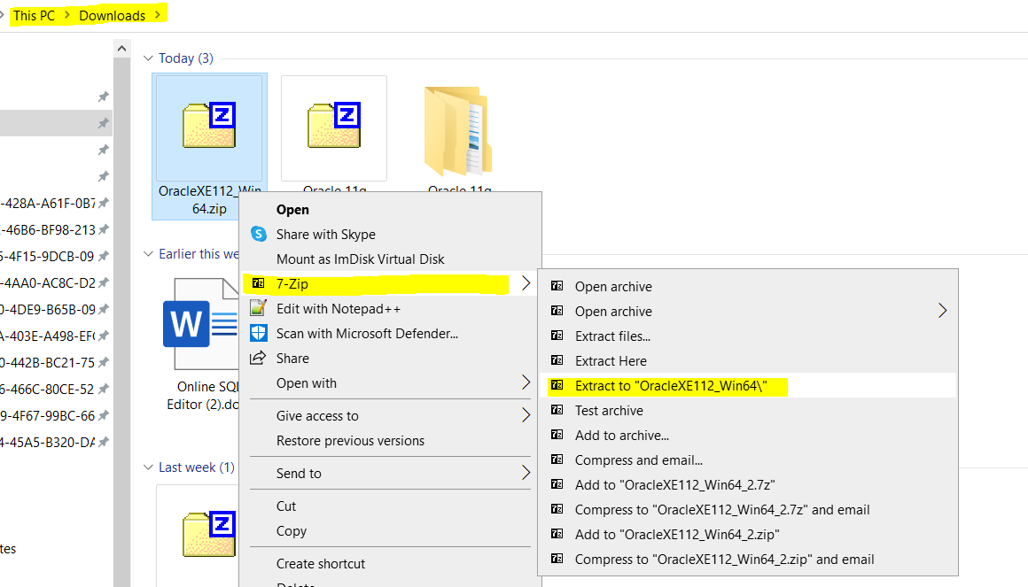
Open the extracted file and double click on setup.exe
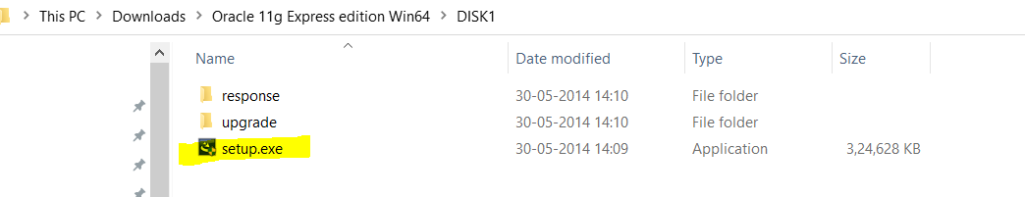

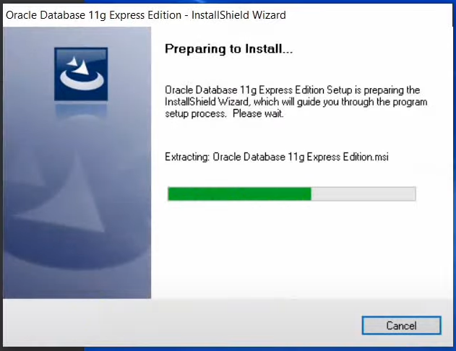

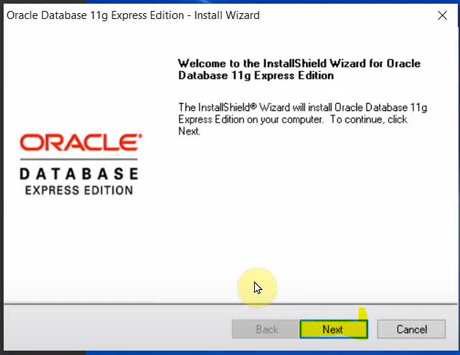

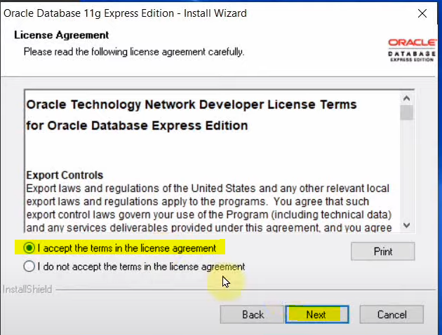

Note – Please set oracle as password in below popup window, this is SYSTEM password which will be use at the time of Connection to SYSTEM USER.
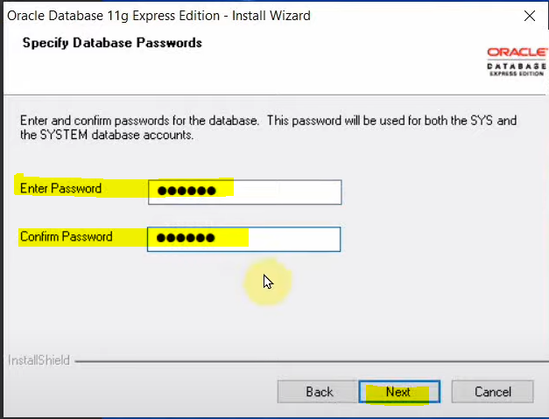
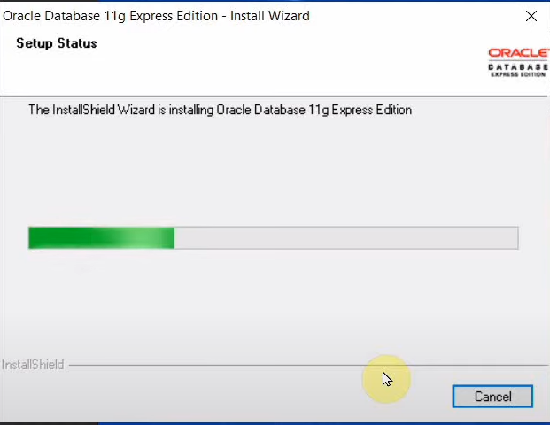

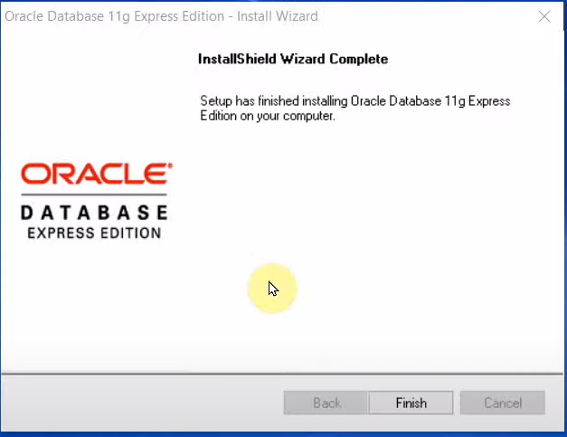

Click on Finish

Now open window search box and type SQL and open Run SQL Command Line
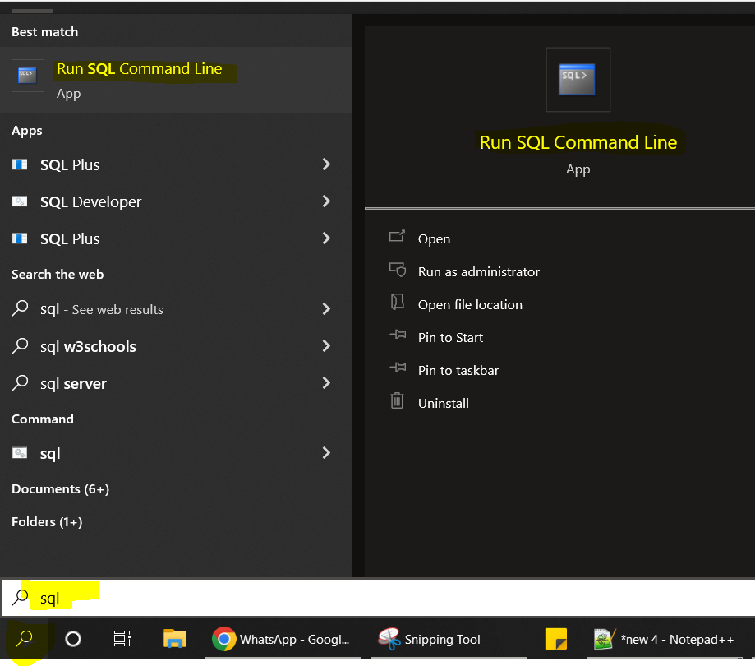

Click on Open
Type – conn (and press enter button)
Enter user name – system (and press enter button)
Provide password – oracle (and press enter button)
Note – When you type password, it will not be visible to you on screen. So just type correct password and click on enter button.

Once Connected type and run below command.
select username, account_status from dba_users;
Click enter button.
It will show the status of user.
Now Type and run below command one by one.
Alter user HR identified by hr;
Alter user HR account unlock;

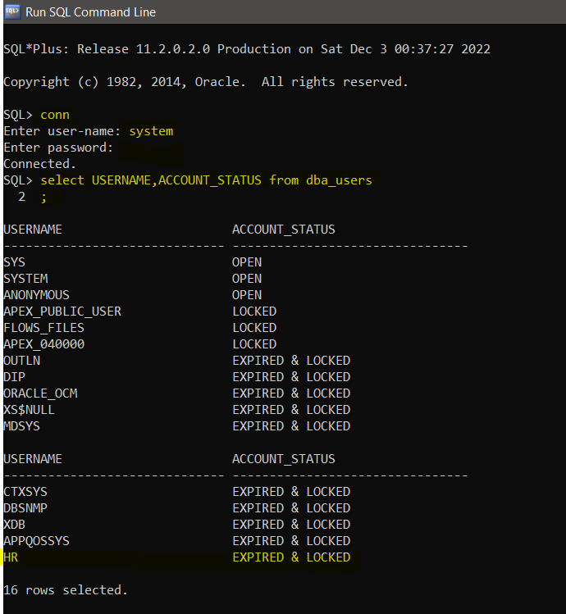

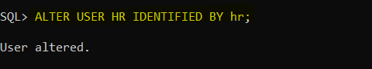
Here User name is HR and password is hr
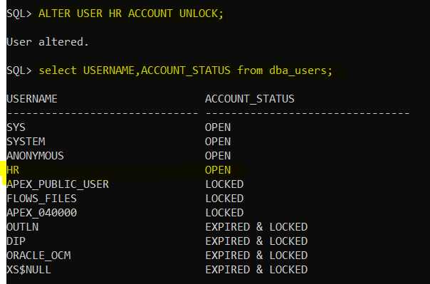

--------------------------------------------------------------------------------------------------------------------------------------
Connection using SQL Developer

Now Install SQL Developer on Windows 10
Click or Go to Below link to download the SQL Developer-
https://drive.google.com/file/d/19KtLMV0Fr9IsqCsbEIX6Y87EFvepX_Qp/view?usp=sharing
Click on Download -
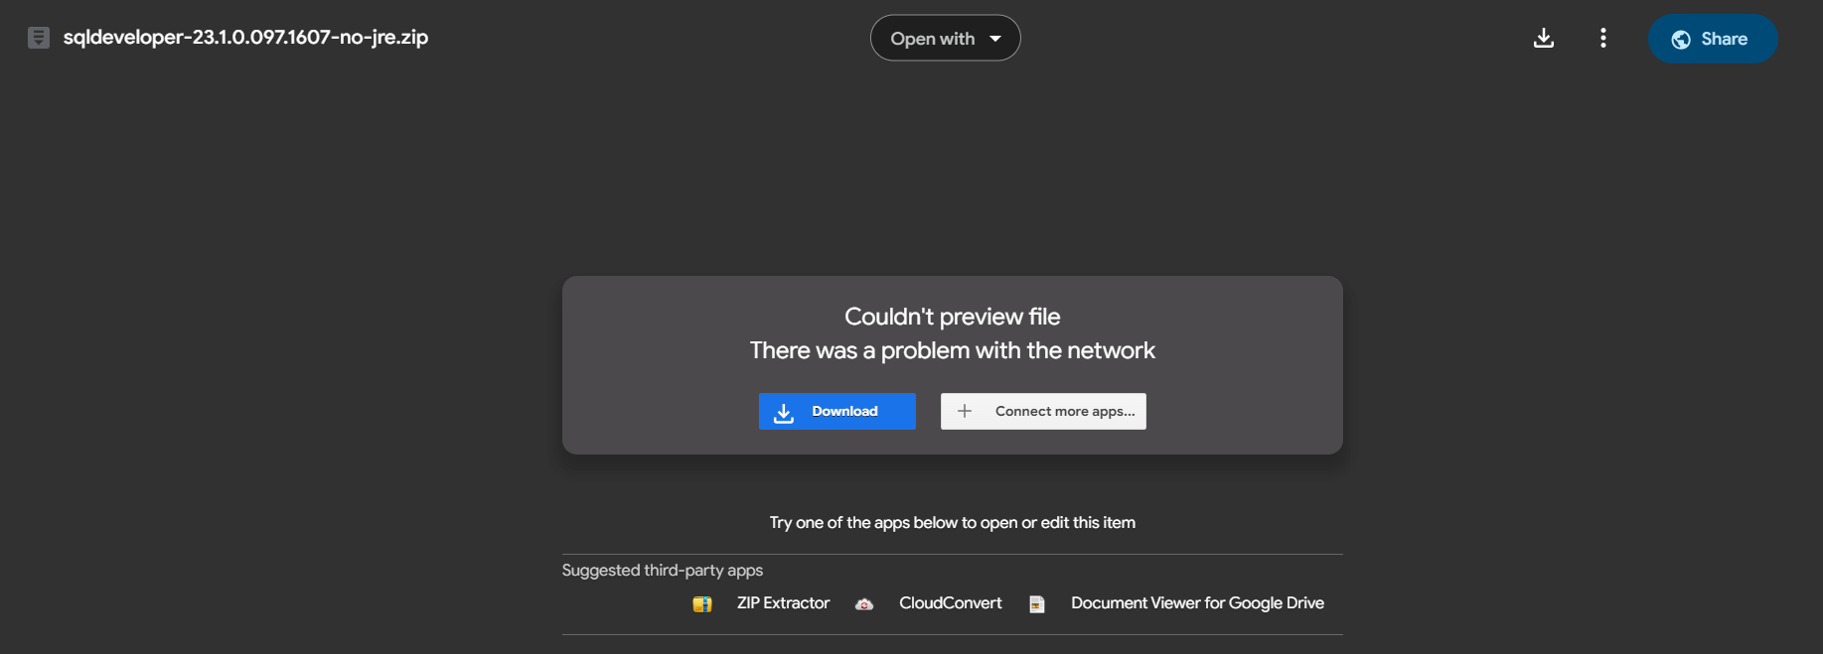

Once download completed – copy the zip file from download folder and paste it into SQL Folder and extract its content there.

Now Open the folder and right click on sqldeveloper.exe file and Run As Administrator
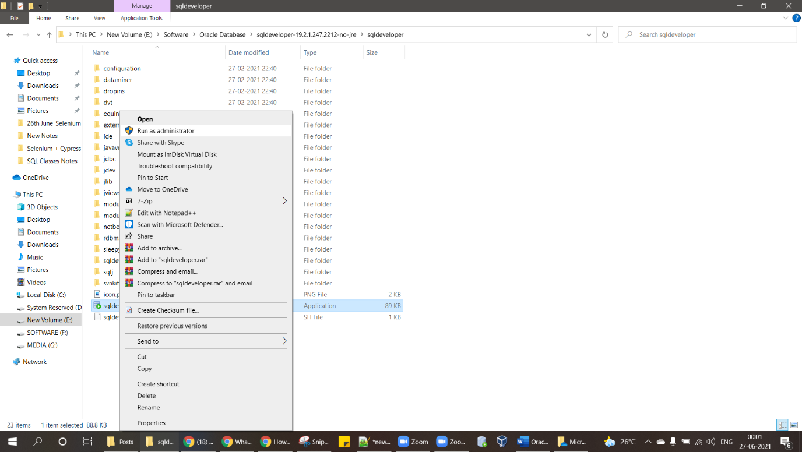

It will start Installing sql developer
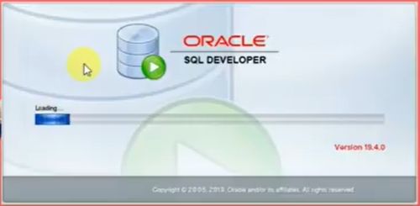
Click on OK
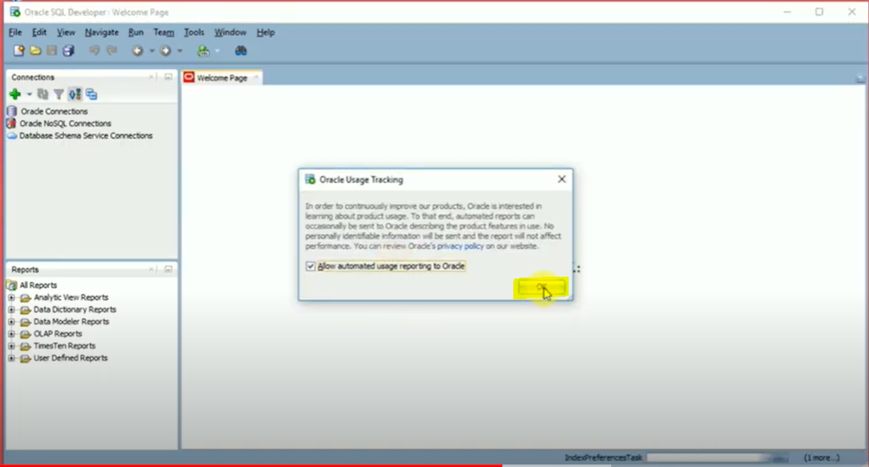

Click on + Symbol to create connection with Database -
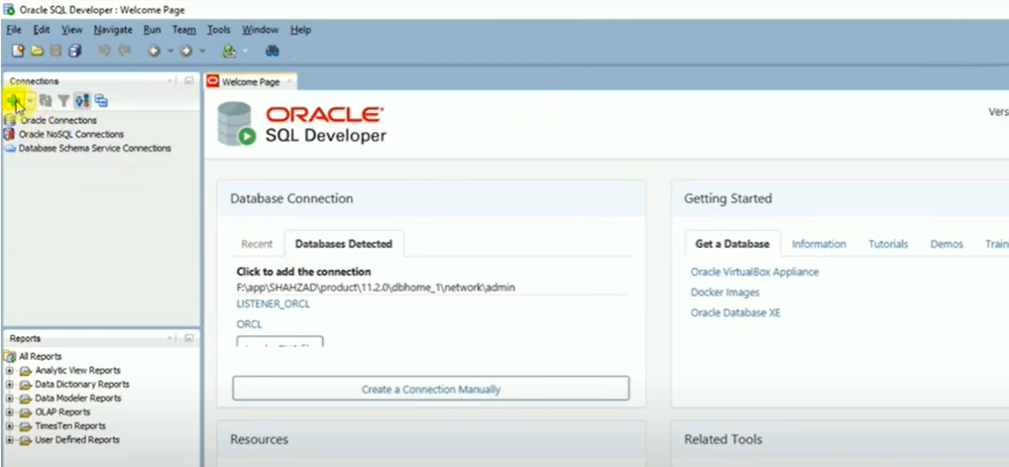

Connection using SQL Developer to SYS or SYSTEM User
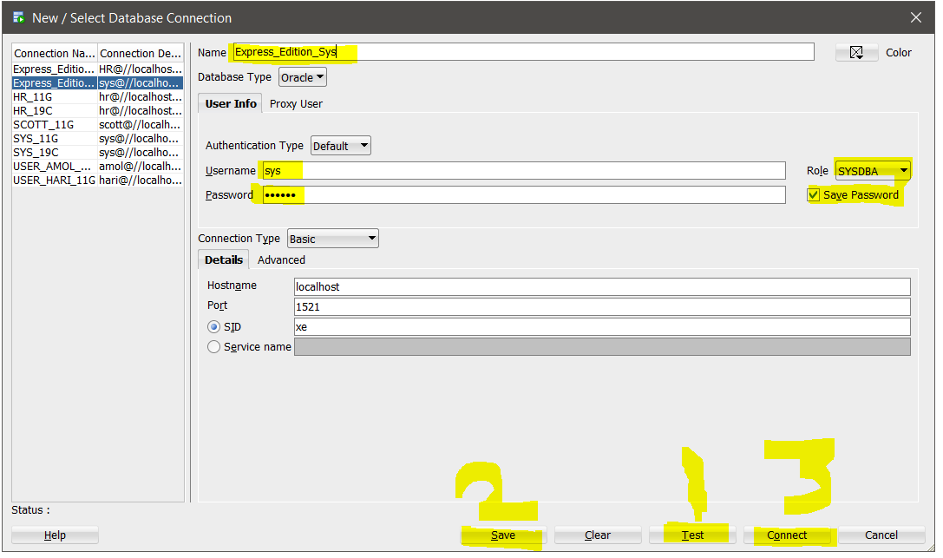

Name – Any Suitable Name
Username – sys
Password – Provide the password which we provided at the time of installing Database
Hostname – keep As it is, No need to change
Role – Select SYSDBA from Drop down
Click on Save Password
First Click on Test Button
Second Click on Save Button
Third Click on Connect Button

Connection using SQL Developer to HR User

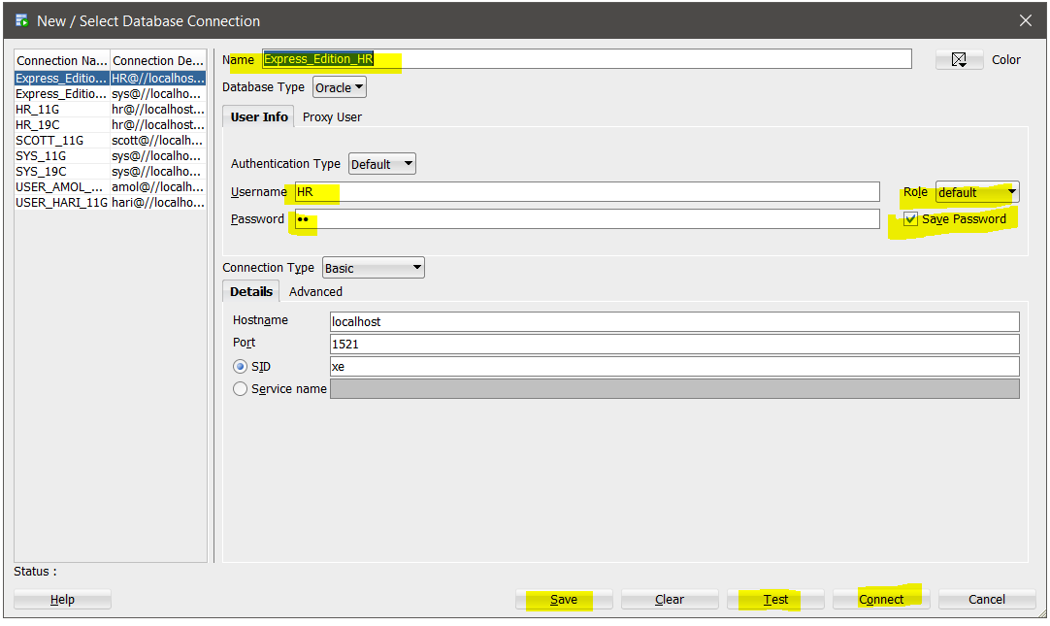

You are good to go. Thank You.

